Assignment-13.4
A.RISHWANTH
2303A52379
Batch 42

Task-1:RefactoringDataTransformation
Logic PROMPT:
Writea Python program todouble eachnumber in alist. Add proper commentsanda docstring explaining the program.
Legacy Code:
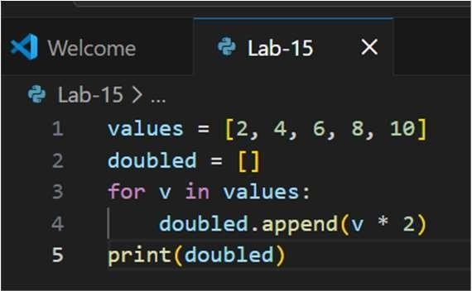
Refactored Code:
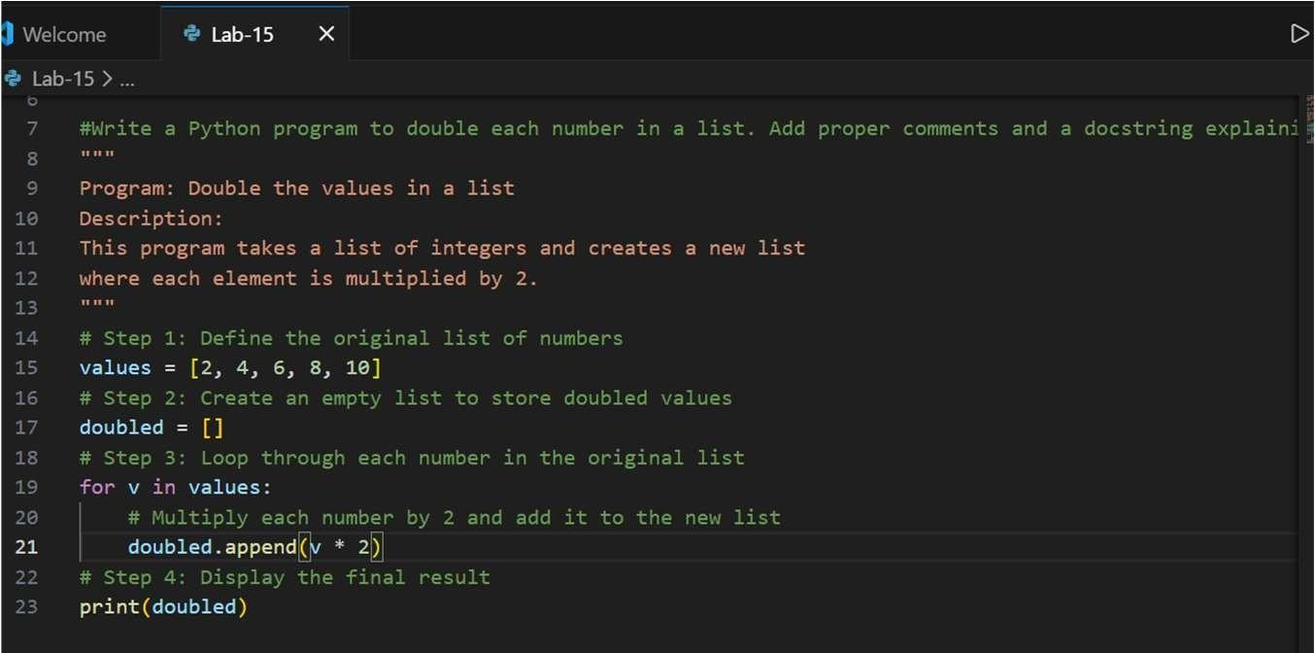
OUTPUT:
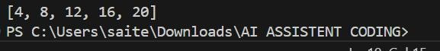
EXPLANATION:
This program creates a list of numbers [4,8,12,16,20] and then uses a loop to go through eachnumber one by one. Foreverynumber inthe list, it multiplies the number by 2and adds the result to a new list called doubled. After the loop finishes, the program prints the new list, which contains all the original numbers multiplied by 2.
Task-2:Improving TextProcessingCode Readability PROMPT:
Refactor the given Python code that builds asentence using string concatenation inside a loop. Improve efficiency and readability while keeping the output unchanged.
Legacy Code:
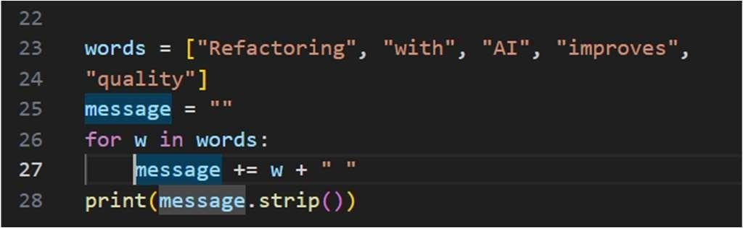
Refactored Code:
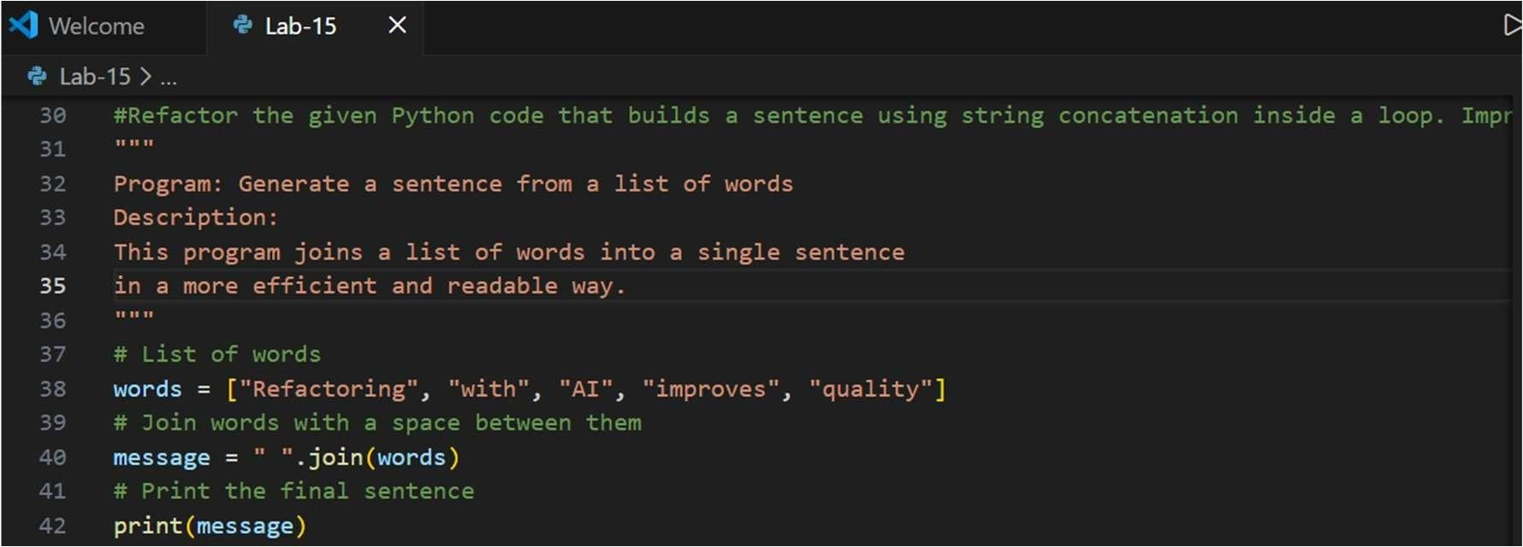
OUTPUT:
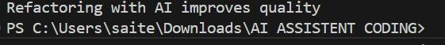
EXPLANATION:
The original code used a loop to add each word to a string one by one, which is less efficient because strings are immutable in Python. Every time a word is added, anew string is created. The improvedversionuses the join() method, which combinesall the words in the list into a single string with spaces in between. This method is faster, cleaner, and easier to read while producing the same output:Refactoring with AI improves quality.
Task-3: Safer Access to Configuration Data PROMPT:
Refactor the given Python codeto safelyaccess dictionary values usingabetter method instead of manually checking for keys. Keep the output unchanged if the key is missing.
Legacy Code:
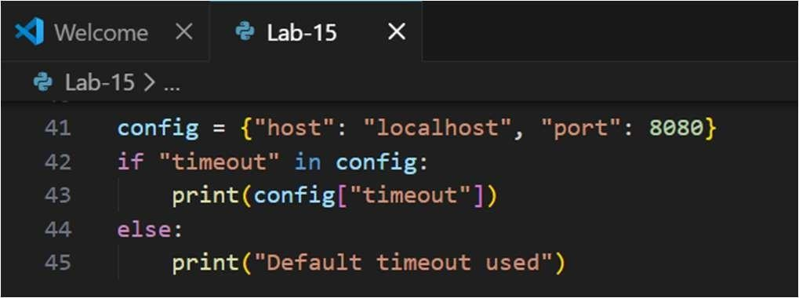
Refactored Code:
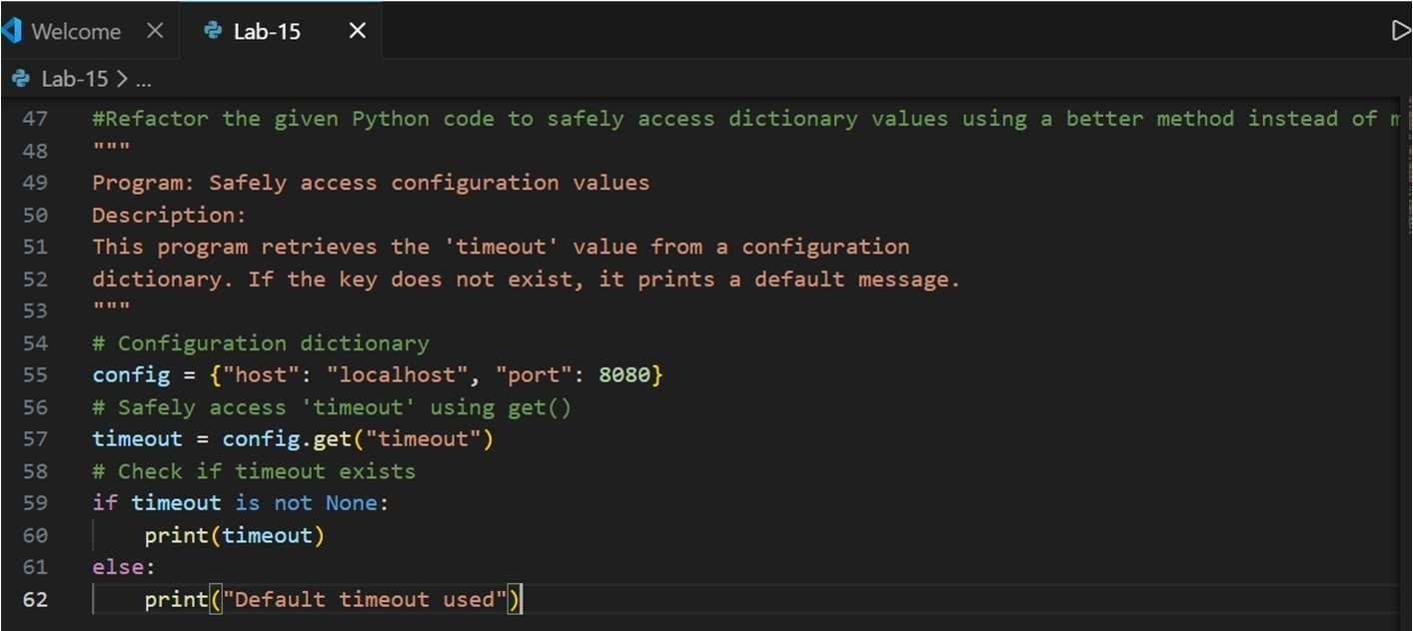
OUTPUT:
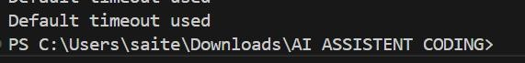
EXPLANATION:
The original code manually checks whether the key "timeout" exists in the dictionary before accessing it. This works but makes the code longer. The improved version uses the get() method, which safelyretrieves the valueof a key. Ifthe key does notexist, it returnsa defaultvalueinsteadof causingan error. This makes thecode shorter,cleaner, and safer while keeping the same output: Default timeout used.
Task-4:Refactoring Conditional Logic for Scalability PROMPT:
Refactor the given Python code that uses multiple if–elif conditions to perform operations. Replace it with acleaner and more scalablemapping-based approach while keeping the same output.
Legacy Code:
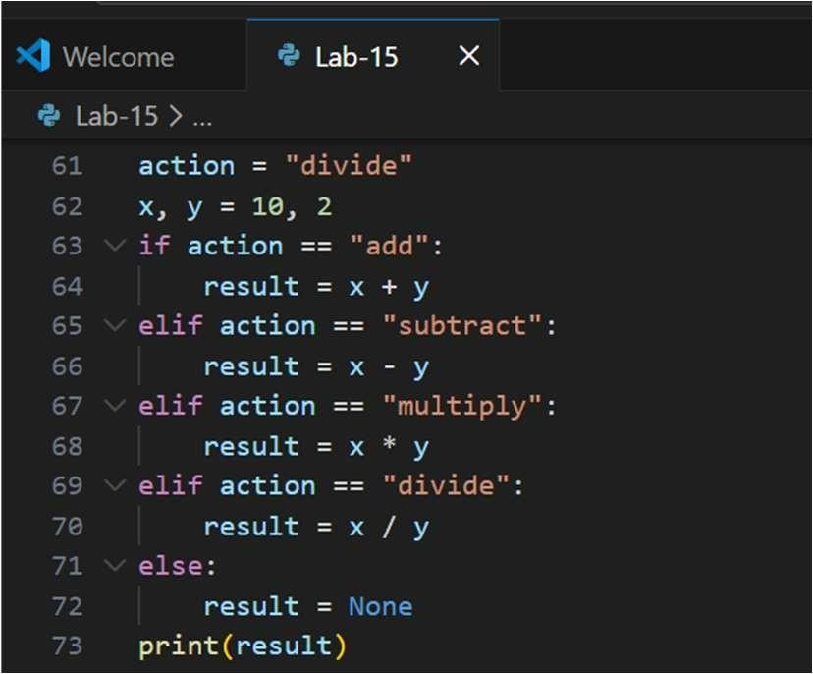
Refactored Code:
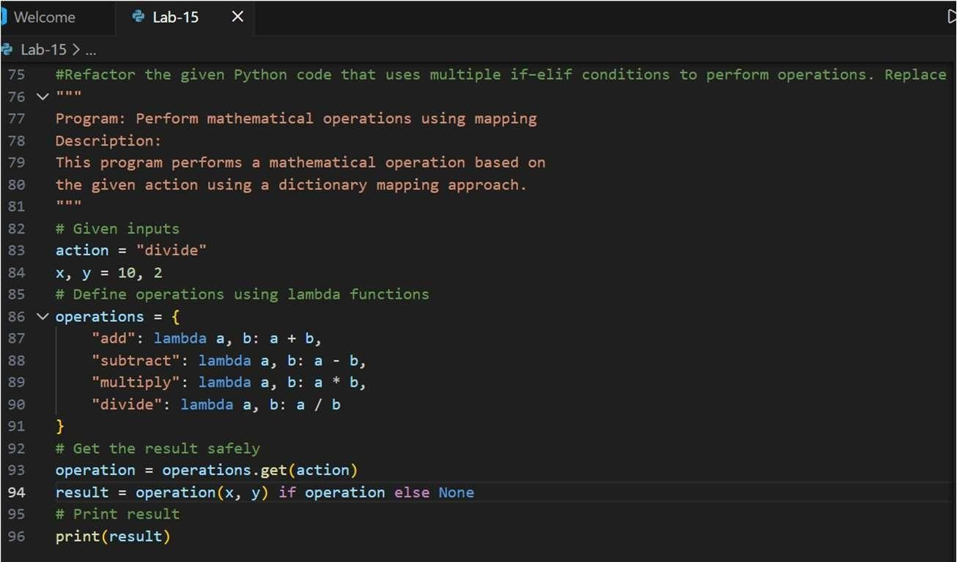
OUTPUT:
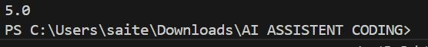
EXPLANATION:
The original code used multiple if–elif conditions tocheck which operation to perform.
While it works, it becomes harder to maintain when more operations are added. The refactoredversionuses a dictionary called operations that maps action names tosmall functions (lambda functions). This makes the code cleaner and easier to expand. If a new operation is needed, we can simply add it tothe dictionary insteadof adding more if–elif statements. The functionality remains the same, and the output is still 5.0.
Task-5: SimplifyingSearch Logic in Collections PROMPT:
Refactor the given Pythoncode that manually searches for an item in a list using a loop. Replace it with a more concise and readable approach while keeping the same output.
Legacy Code:
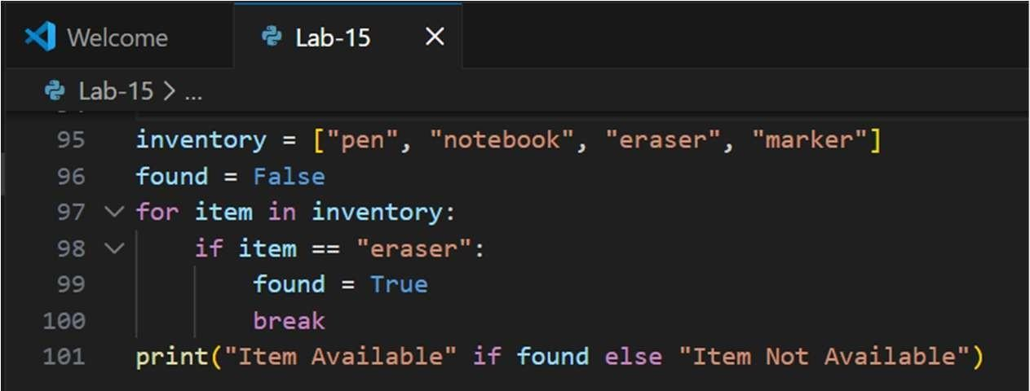
Refactored Code:
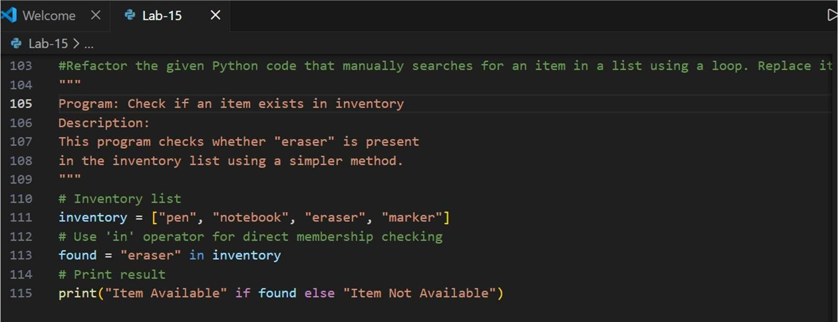
OUTPUT:
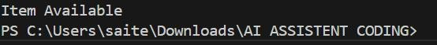
EXPLANATION:
The original code used a loop to check each item in the list one by one and set a flag variable when theitem was found. While this works, it makes the code longer. The improved version uses Python’s in operator, which directly checks whether an item existsinthelist.Thismakesthecodeshorter, easiertoread, andmore efficient while producing the same output: Item Available.

